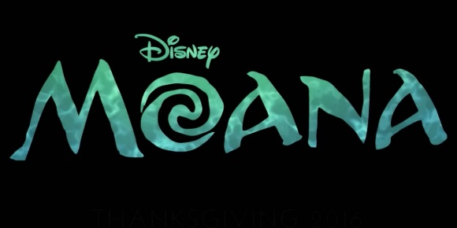

ONLY £20

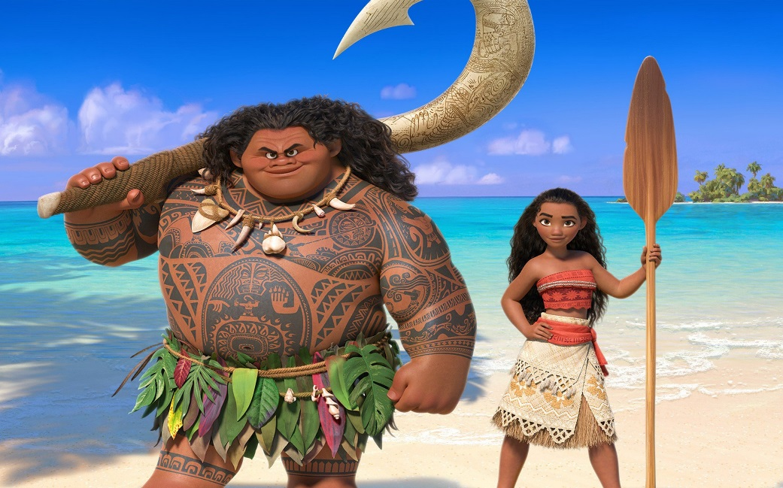

**Sessions:**

**1 - Saturday 20th** **January 1.30pm – 2.30pm**

**2 - Saturday 27th January 1.30pm – 2.30pm**

**3 - Saturday 3rd February 1.30pm – 2.30pm**

**4 - Saturday 10th February 1.30pm – 2.30pm**

**5 – Saturday 17th February 1.30pm – 2.30pm**

Open to all students age 5 and over!

**Perform ‘Where You Are’ from Disney’s ‘Moana’ in this year’s show!**

To join in the fun, make sure you can attend **4 of the 5 sessions**, and submit your registration form and payment **BEFORE** the first session. There are limited spaces, so it will be done on a ‘first come, first serve’ basis.

You can get a form from the waiting area, or email Elysia at [upstageschool@hotmail.com](mailto:upstageschool@hotmail.com).

In order to pay by BACS, bank details are found on the registration form. Cash/cheque paid directly to Elysia are also accepted.

We look forward to seeing you!